**31. Construct a C program to simulate the First in First Out paging technique of memory management.**

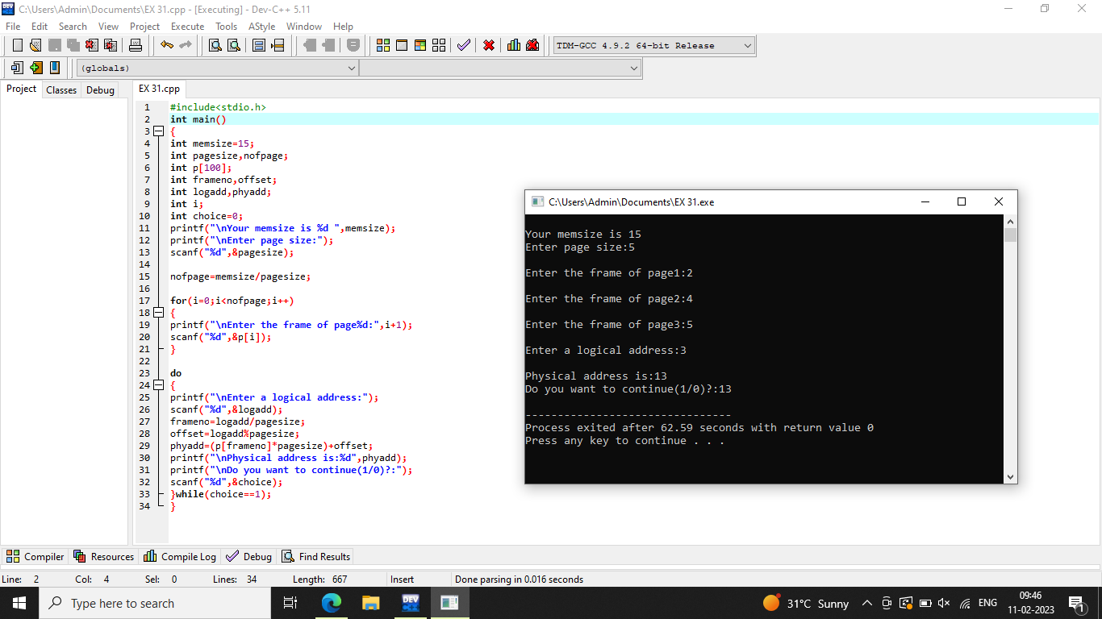

**32. Construct a C program to simulate the Least Recently Used paging technique of memory management.**

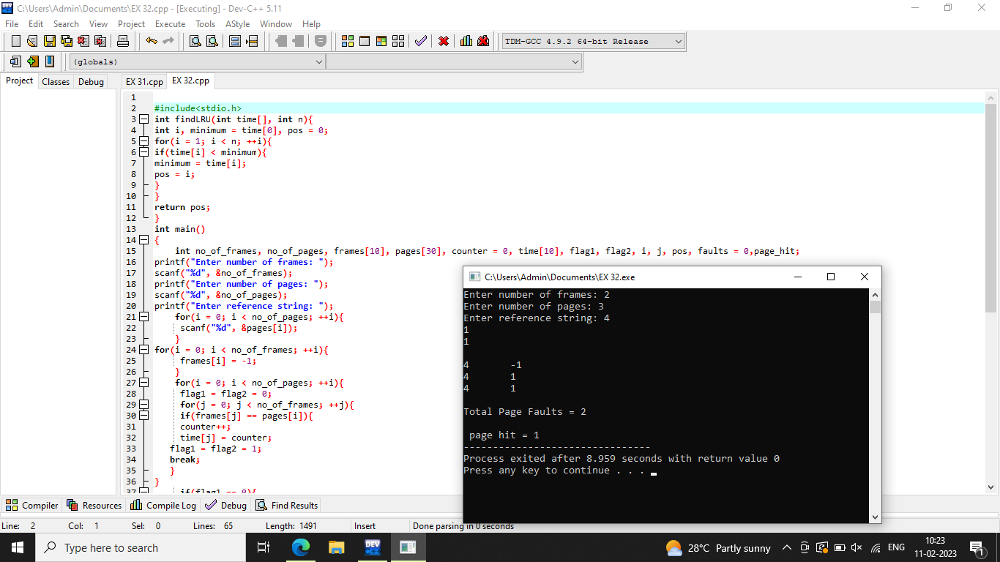

**33. Construct a C program to simulate the optimal paging technique of memory management.**

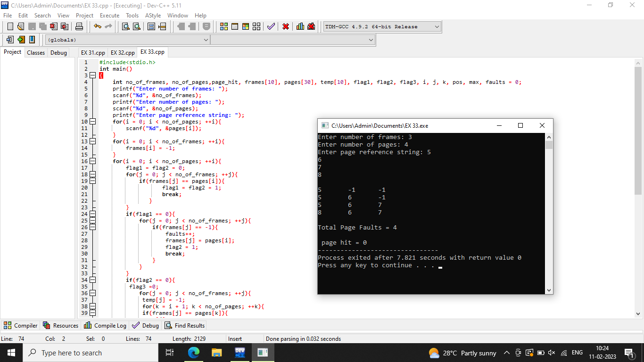

**34. Consider a file system where the records of the file are stored one after another both physically and logically. A record of the file can only be accessed by reading all the previous records.  Design a C program to simulate the file allocation strategy.**

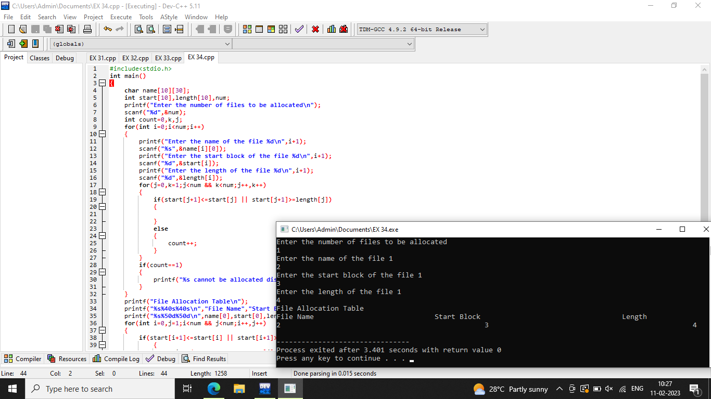

**35. Consider a file system that brings all the file pointers together into an index block. The ithentry in the index block points to the ith block of the file. Design a C program to simulate the file allocation strategy.**

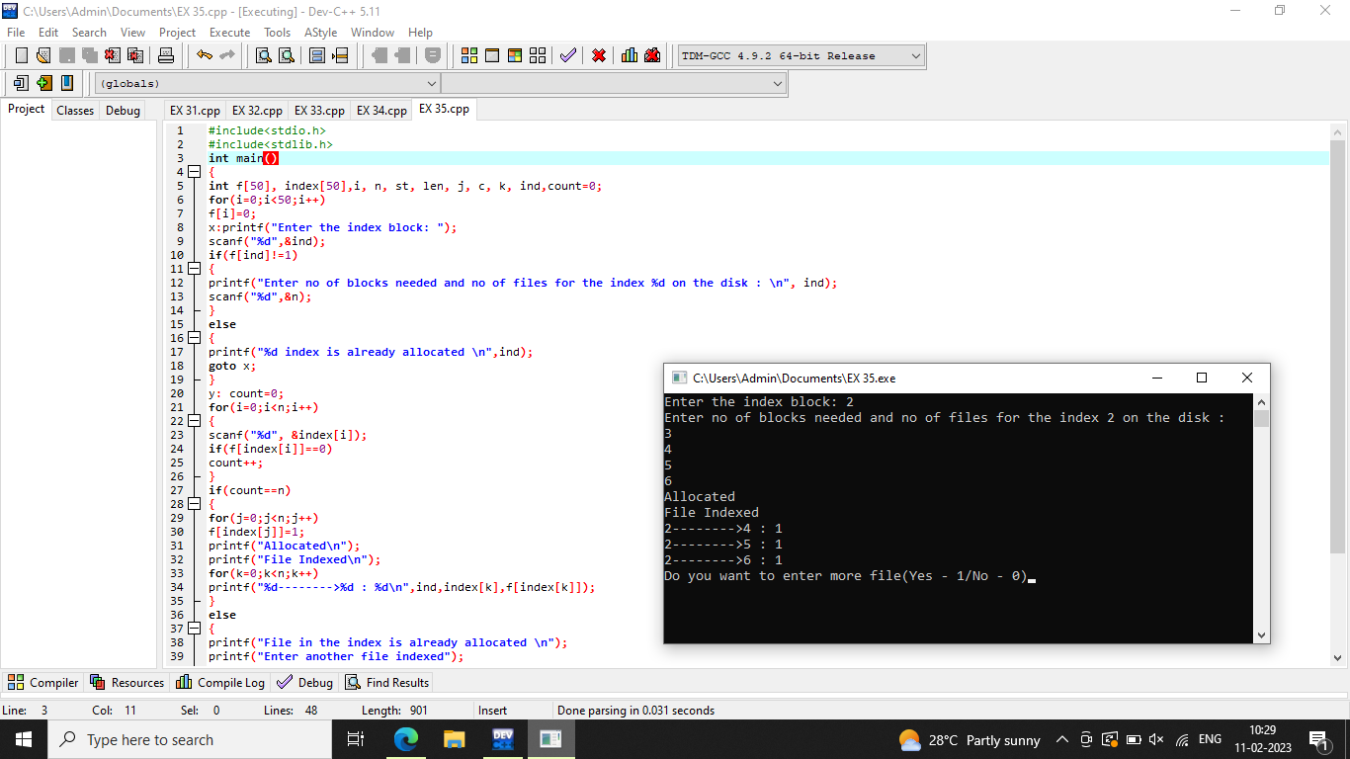

**36. With linked allocation, each file is a linked list of disk blocks; the disk blocks may be scattered anywhere on the disk. The directory contains a pointer to the first and last blocks of the file.  Each block contains a pointer to the next block. Design a C program to simulate the file allocation strategy.**

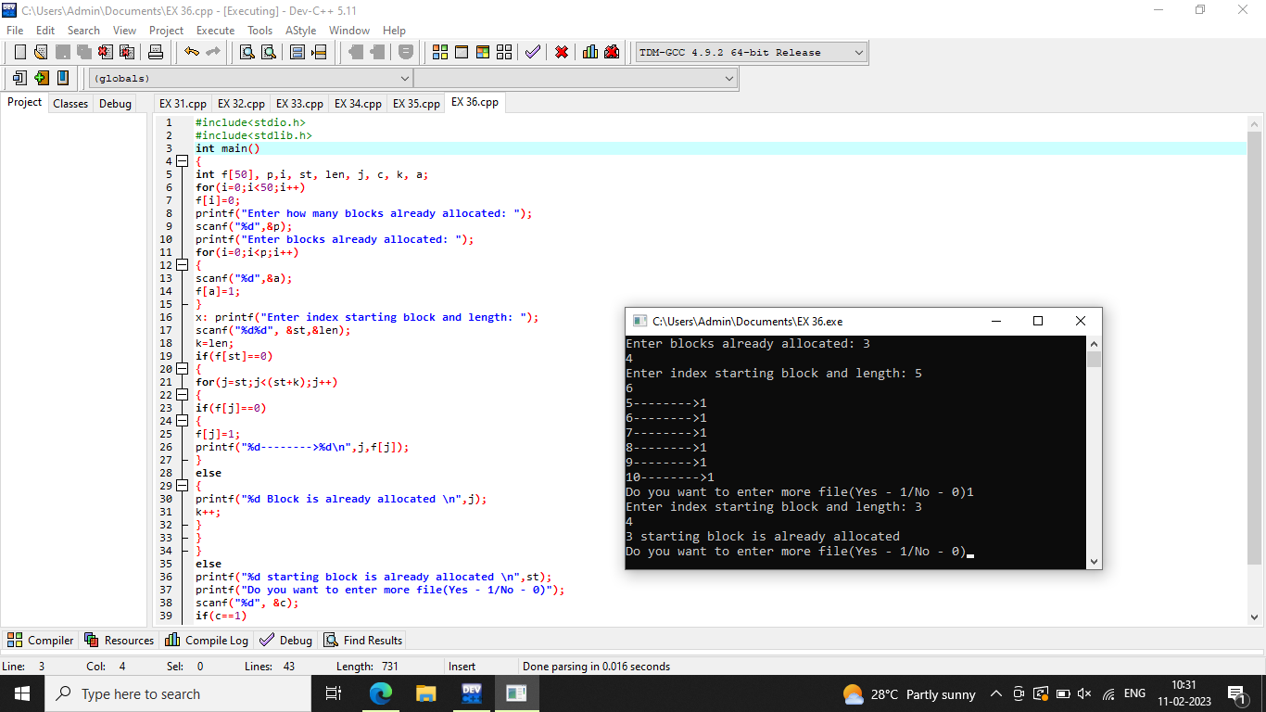

**37.Construct a C program to simulate the First Come First Served disk scheduling algorithm.**

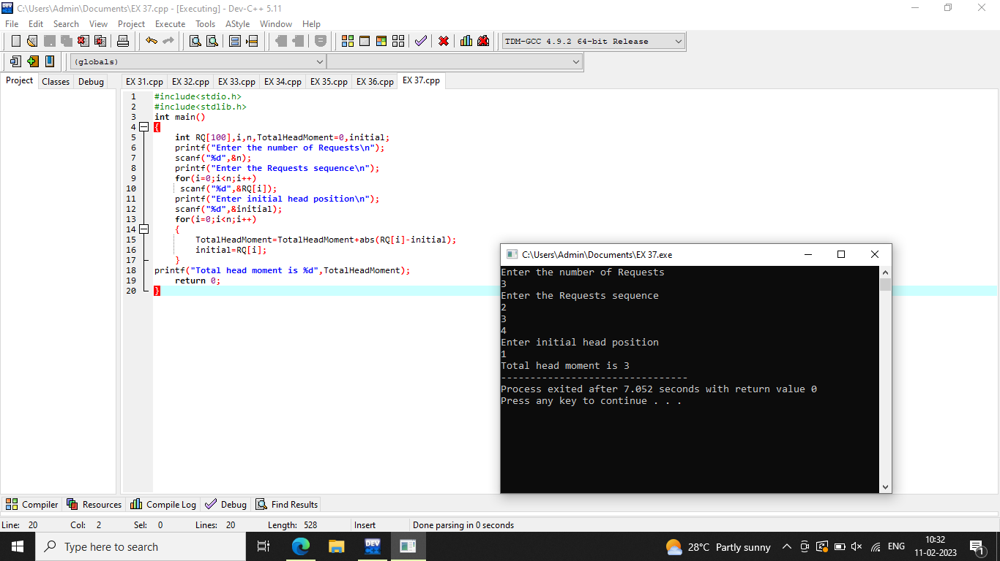

**38. Design a C program to simulate SCAN disk scheduling algorithm.**

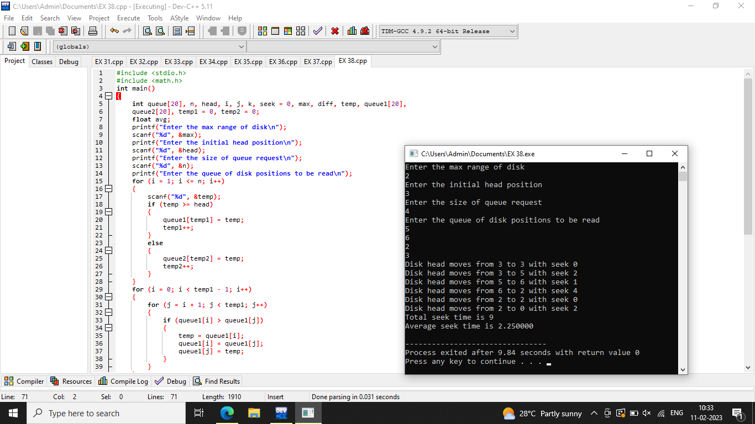

**39. Develop a C program to simulate C-SCAN disk scheduling algorithm.**

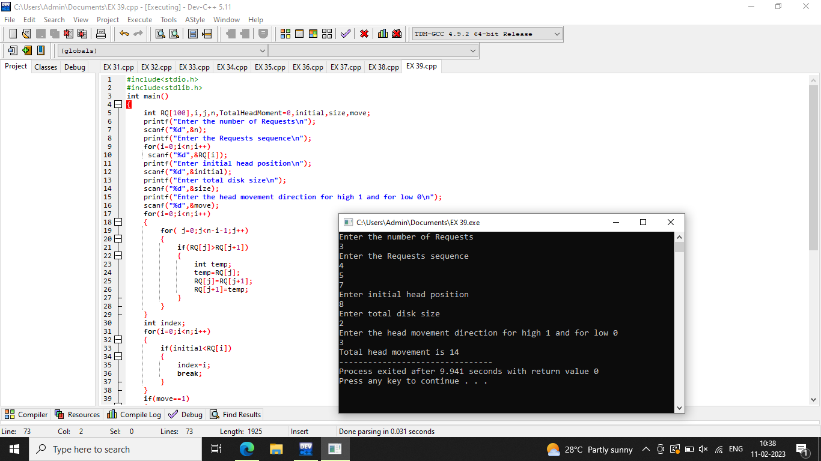

**40. Illustrate the various File Access Permission and different types users in Linux.**

